Capstone Lab 1

Capstone Lab 1.1
Question 5 – Please provide screenshot
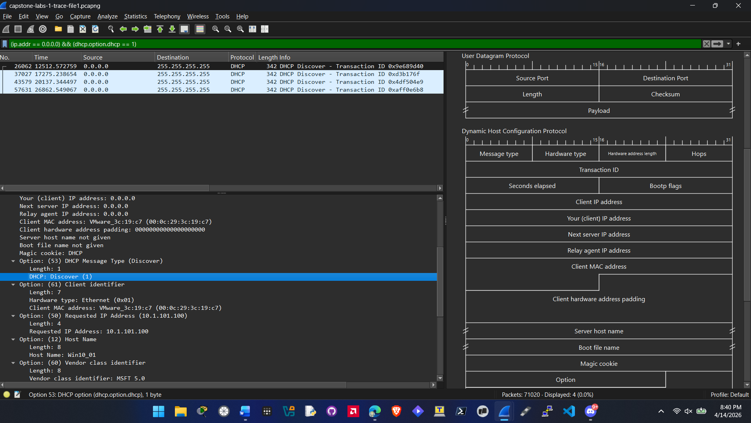
Question 6 – Please answer lab summary question.
In this part of the Captone 1 lab I accomplished 3 things by configuring this filter. I isolated all of the hosts with an ip address of 0.0.0.0 by applying the filter. I also went beyond normal filtering by searching for just he DHCP disover message type and adding that to the filter. By doing both of these it makes a combination filter that meets both the criteria.

Capstone Lab 1.2
Question 5 – Please provide screenshot
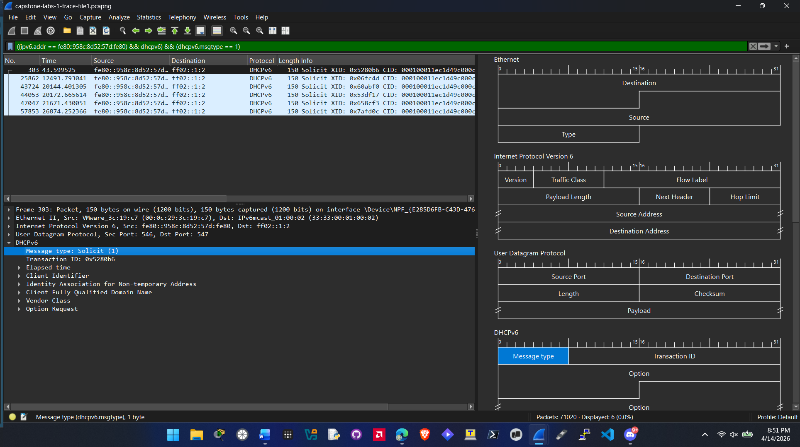
Question 6 – Please answer lab summary question.
In this part of capstone 1 lab I accomplished targeting an Ipv6 host using the filter. I also identified DHCPv6 solicitation packets and then used those packets to apply a filter for packets that have a dhcp solicit (1) message type.

Capstone Lab 1.3
Question 5 – Please provide screenshot showing this information, rather than writing it down.
IPv4: Version 2
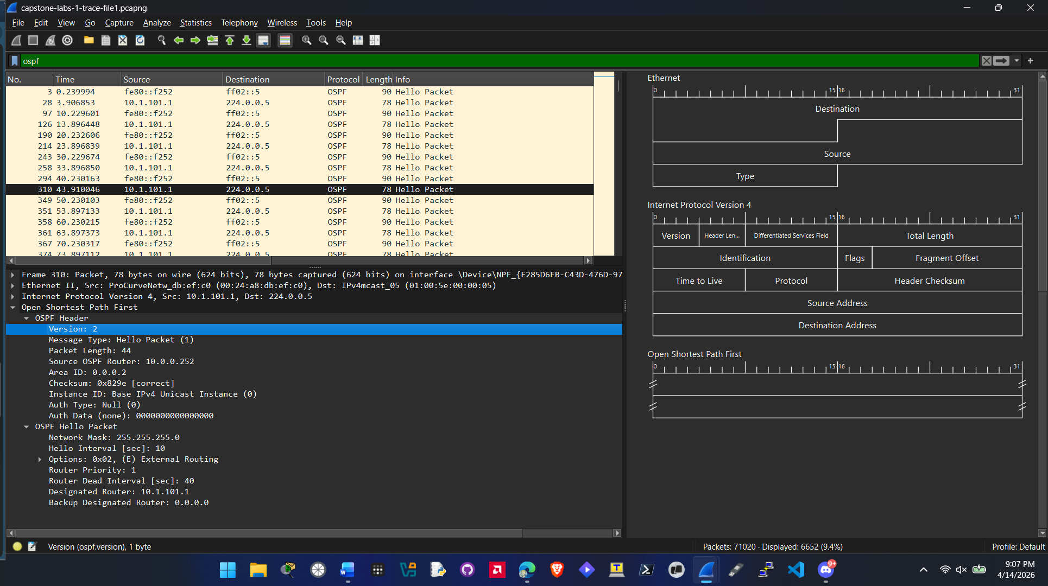
IPv6: version 3
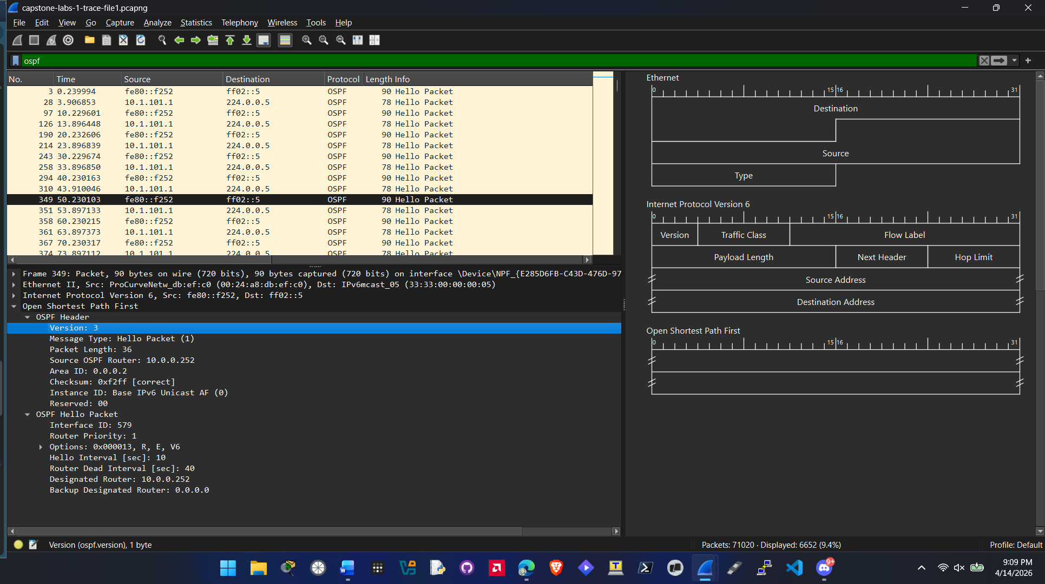
Question 7 – Please answer lab summary question.
In this capstone lab I identified the protocol ospf and set a display filter for it. Then I inspected the OSPF packet header and identified which version of OSPF is used between IPv4 and IPv6.

Capstone Lab 1.4
Question 8 – Please provide screenshots showing the different router and switches.
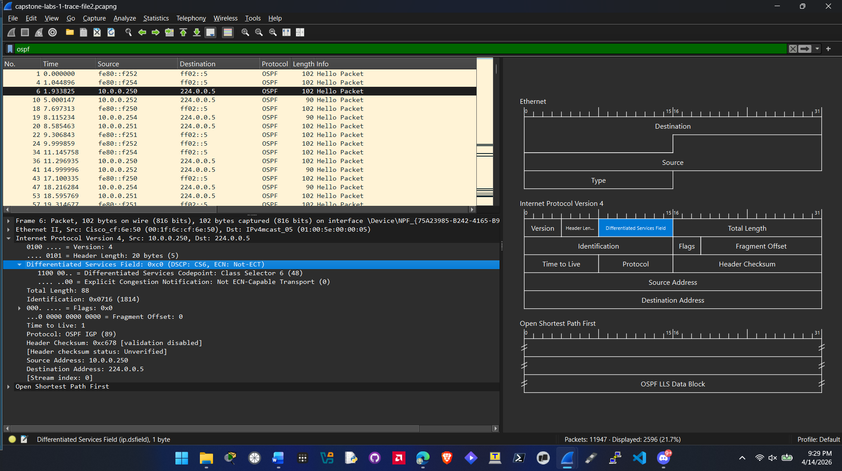
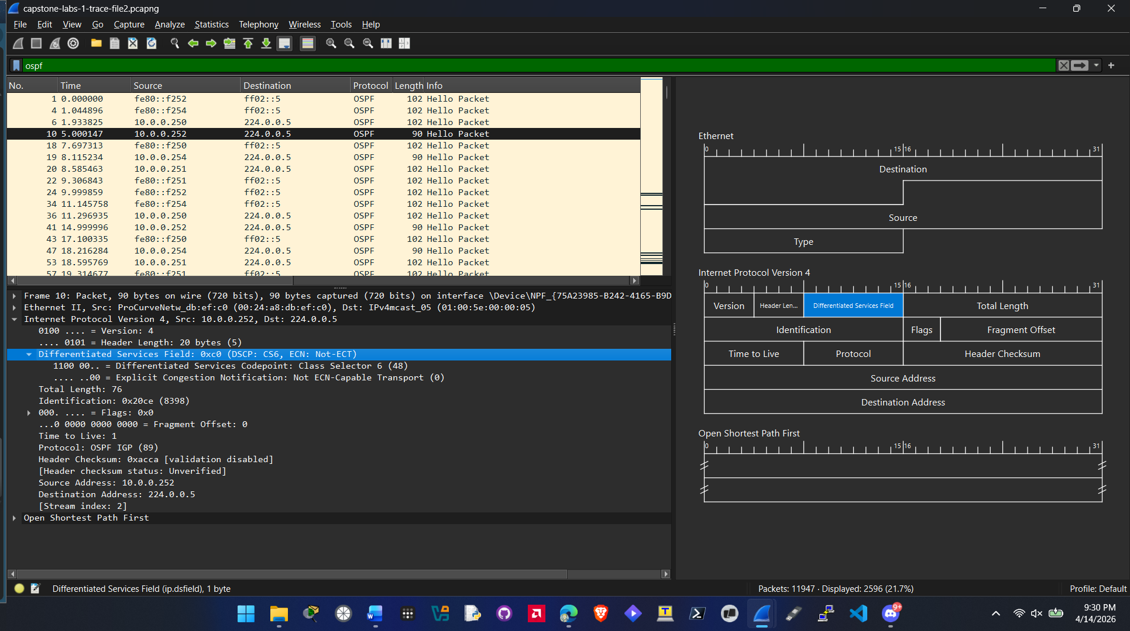
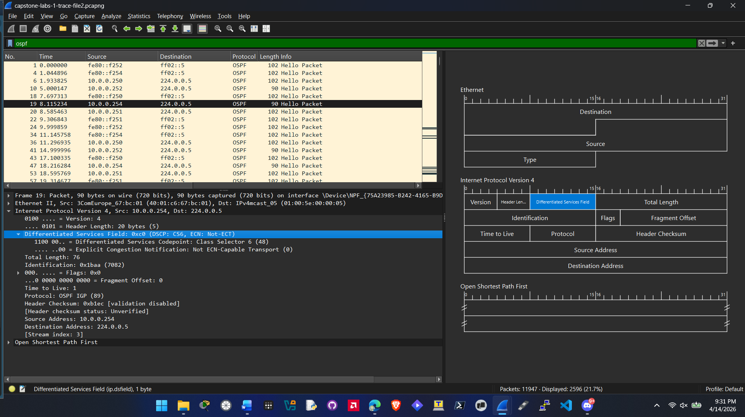
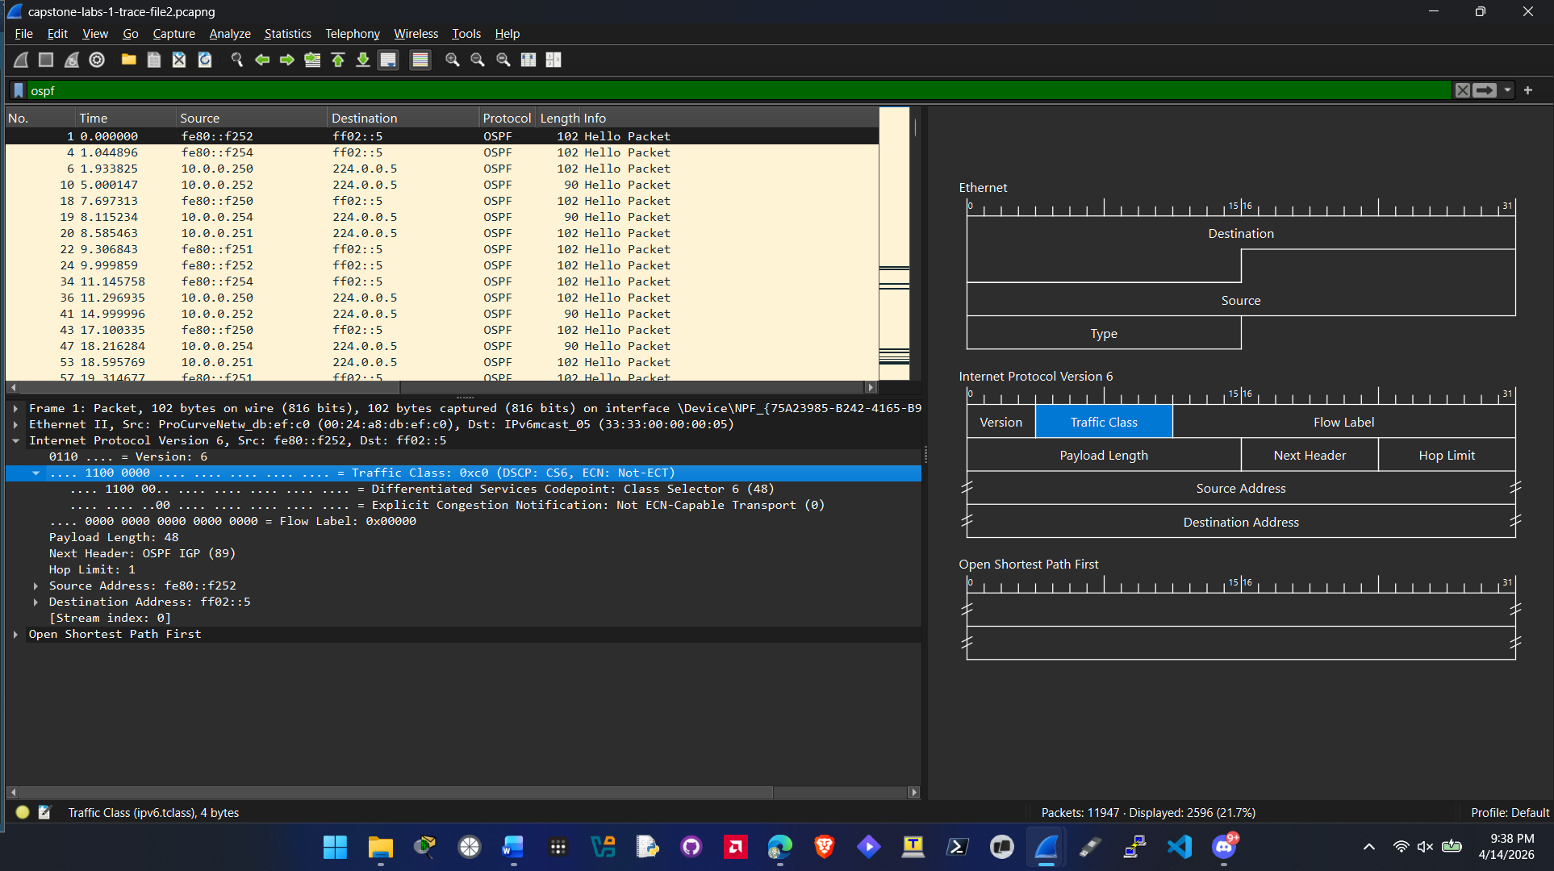
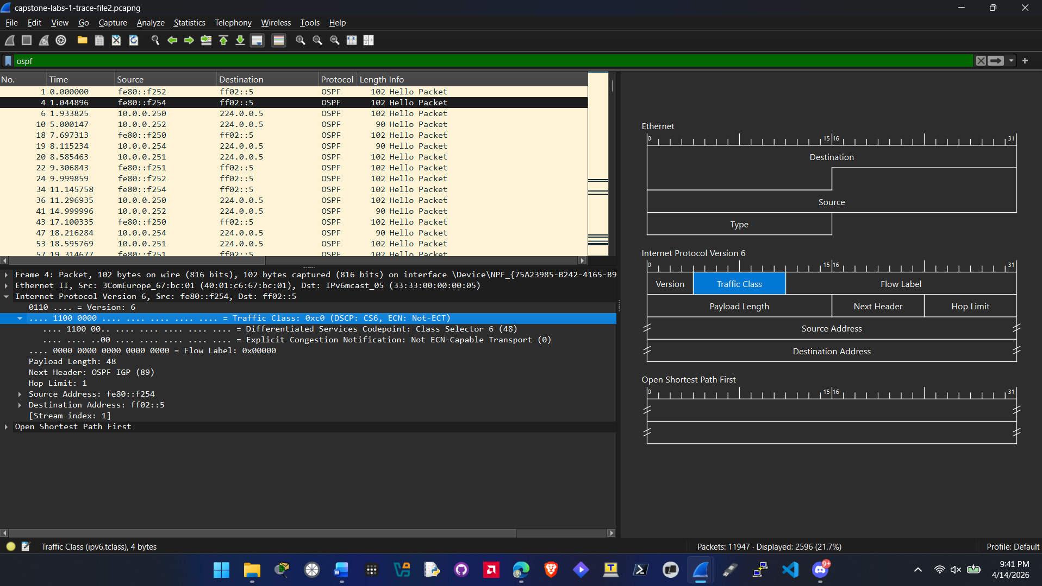
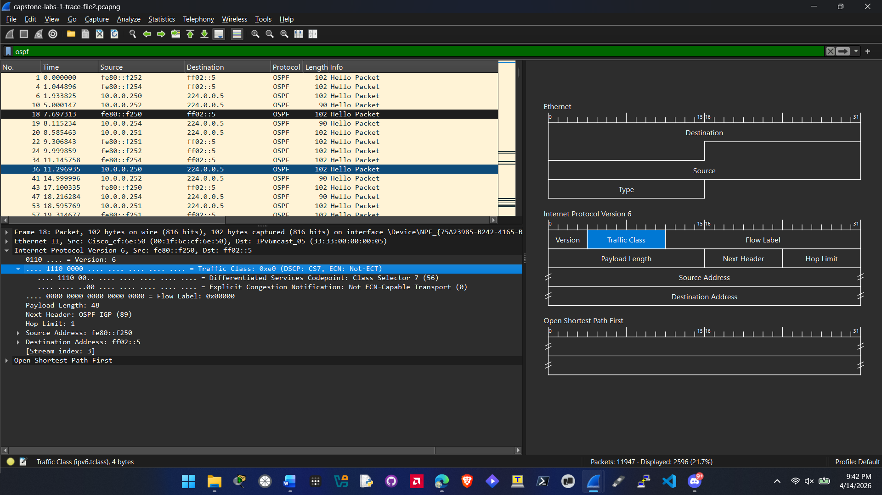

Question 9 – Please answer question.
Cisco_cf:6e:50:
IPv4: 10.0.0.250
IPv6: fe80::f250

Cisco_53:4b:c0
IPv4: 10.0.0.251
IPv6: fe80::f251

ProCurveNetw_db:ef:c0
IPv4: 10.0.0.252
IPv6: fe80::f252

3ComEurope_67:bc:01
IPv4: 10.0.0.254
IPv6: fe80::f254

Question 10 – Please answer lab summary question.
A couple of things were accomplished in this lab. Identifying how vendors tag OSPF traffic. The difference between IPv4 and IPv6 when it comes to OSPF versions. I also identified the devices in this capture and matched them to their IPv4 and IPv6 addresses.

Capstone Lab 1.5
Question 5 – Please provide screenshot showing the next header and layer 4 protocol.
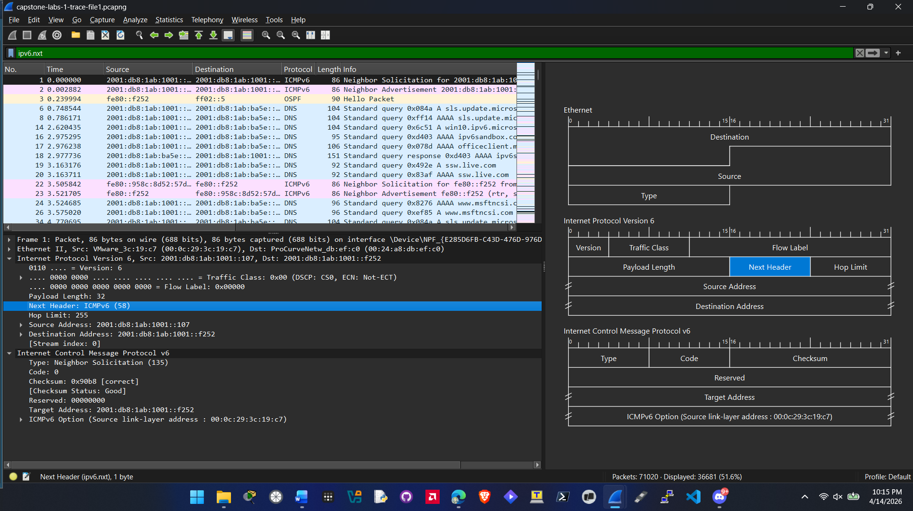
Question 7 – Please provide screenshot showing the next header and layer 4 protocol for a different packet.
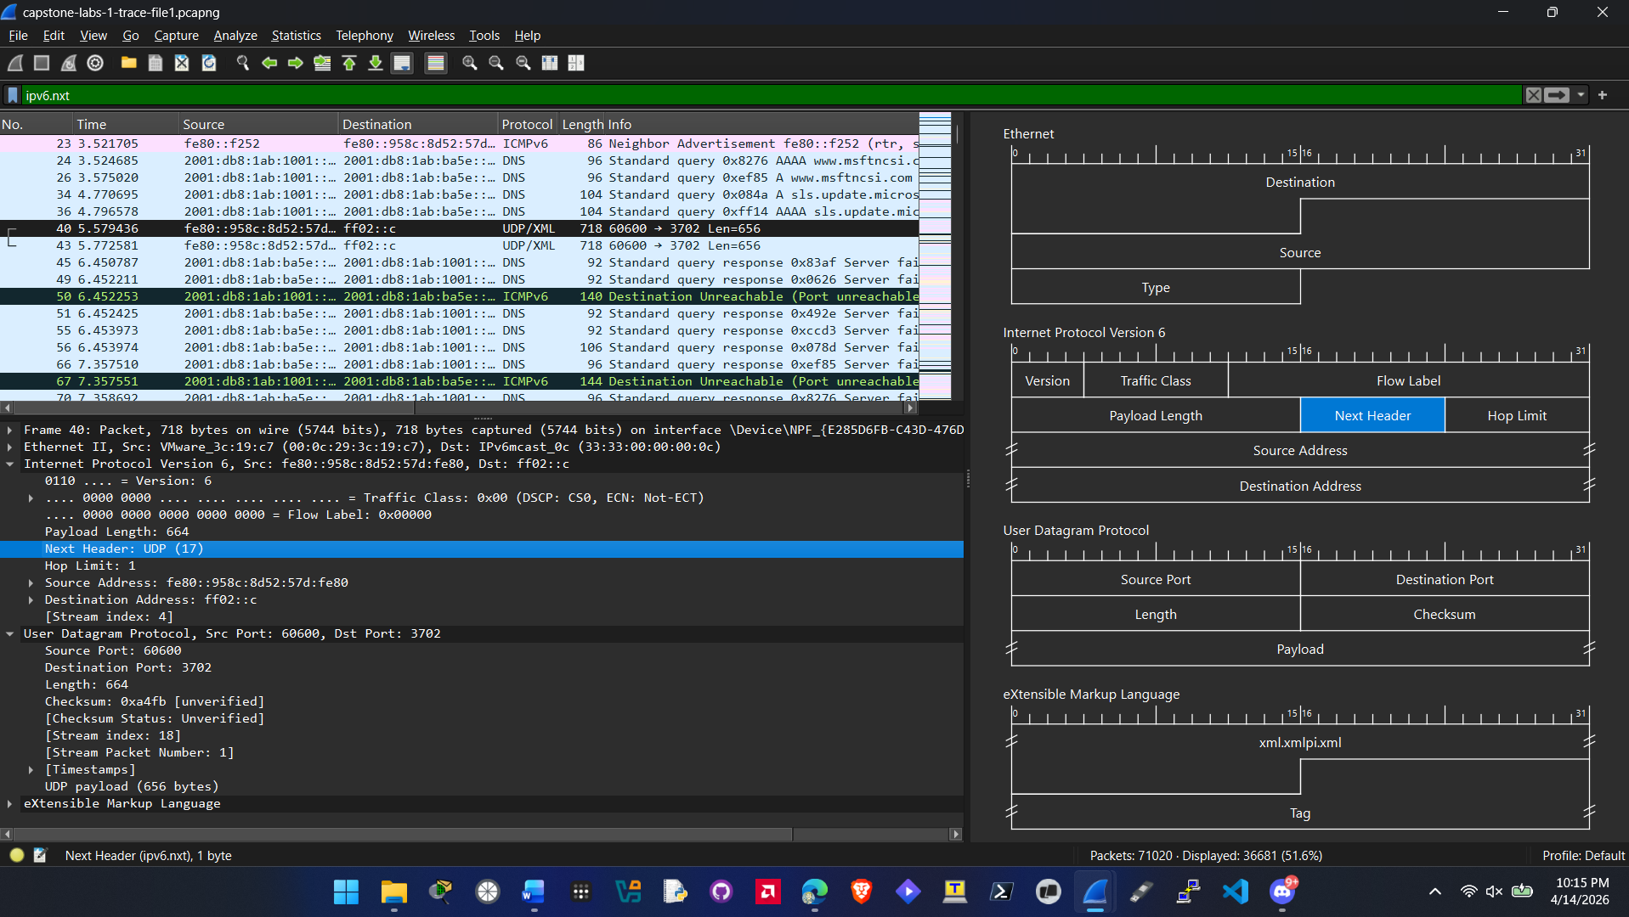

Question 8 – Continue with the requested screenshots.
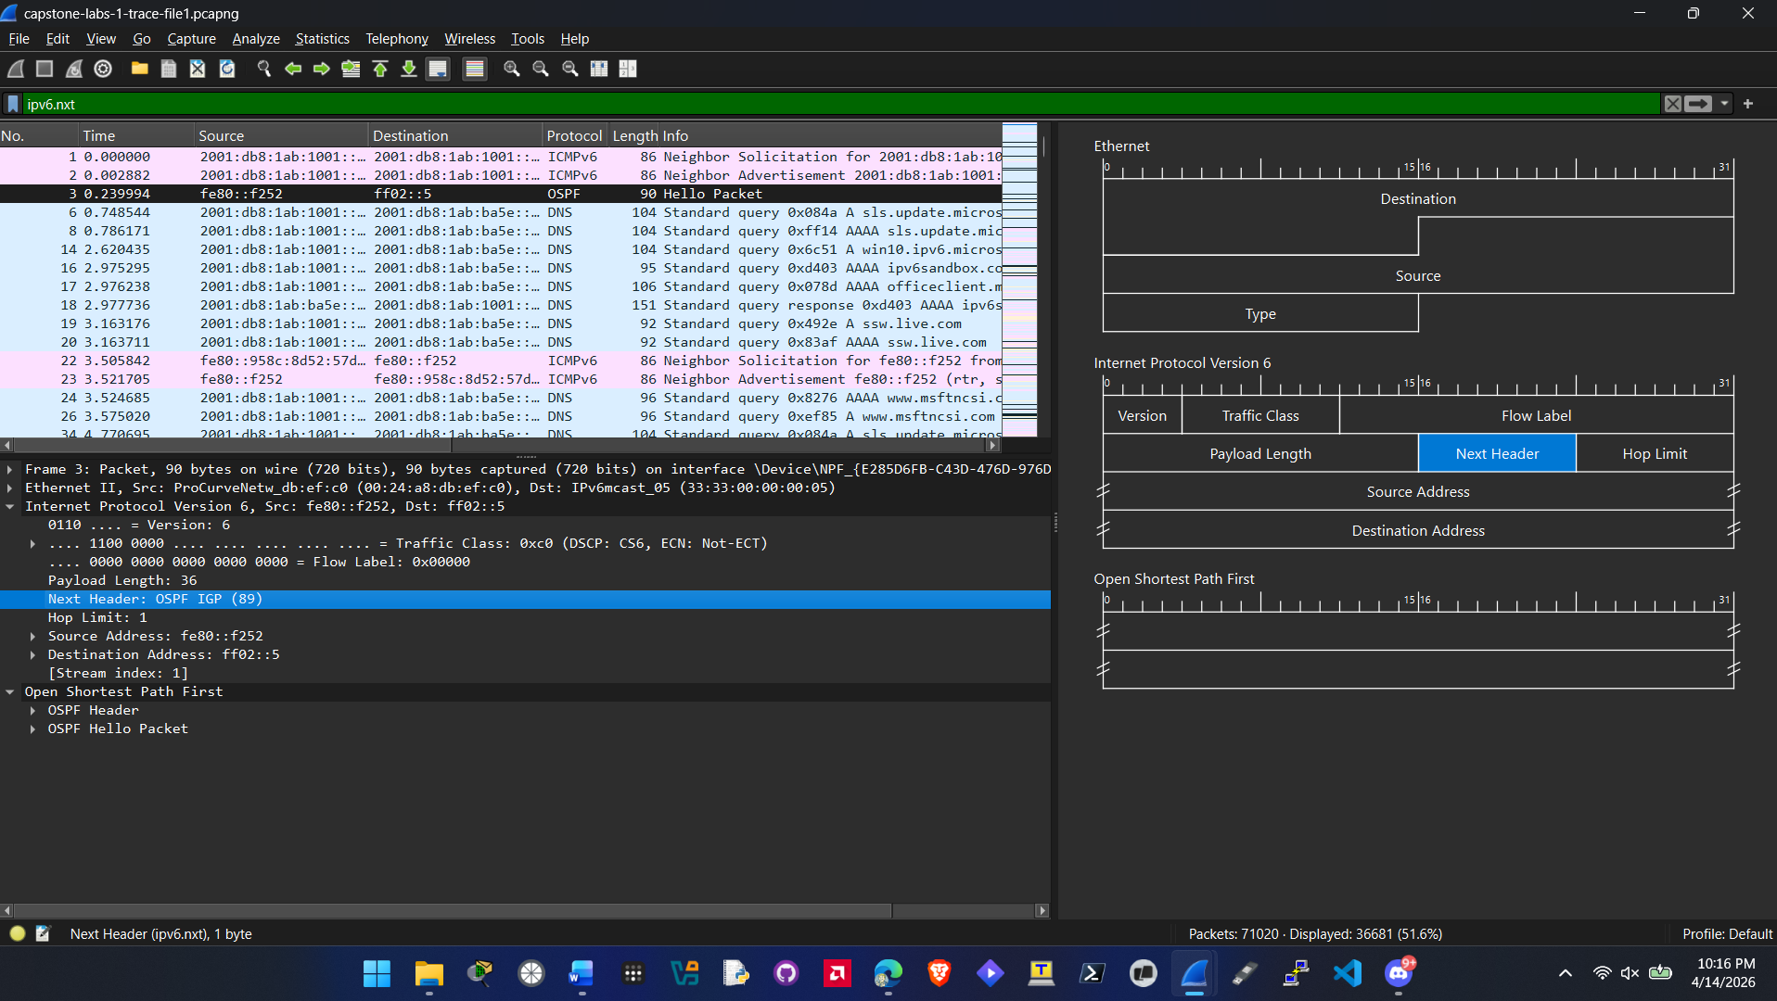
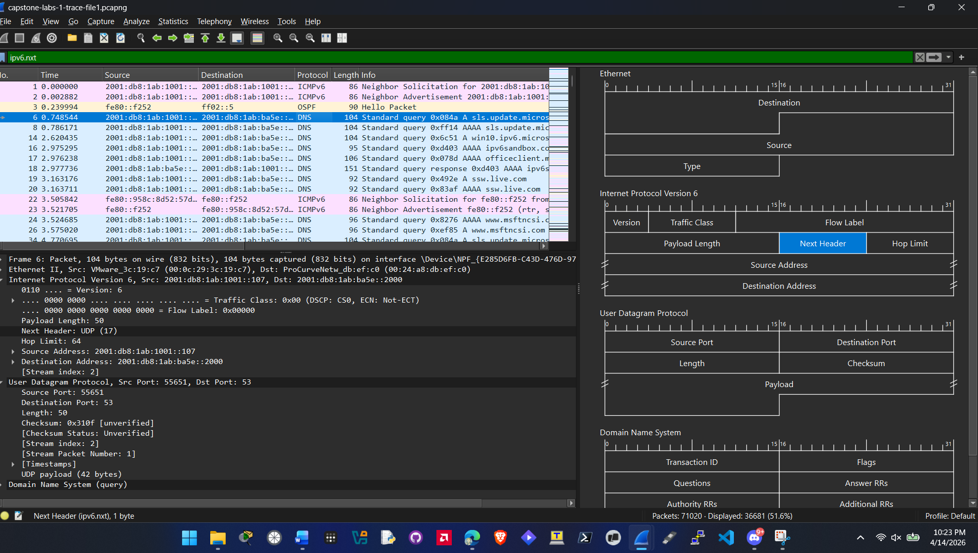

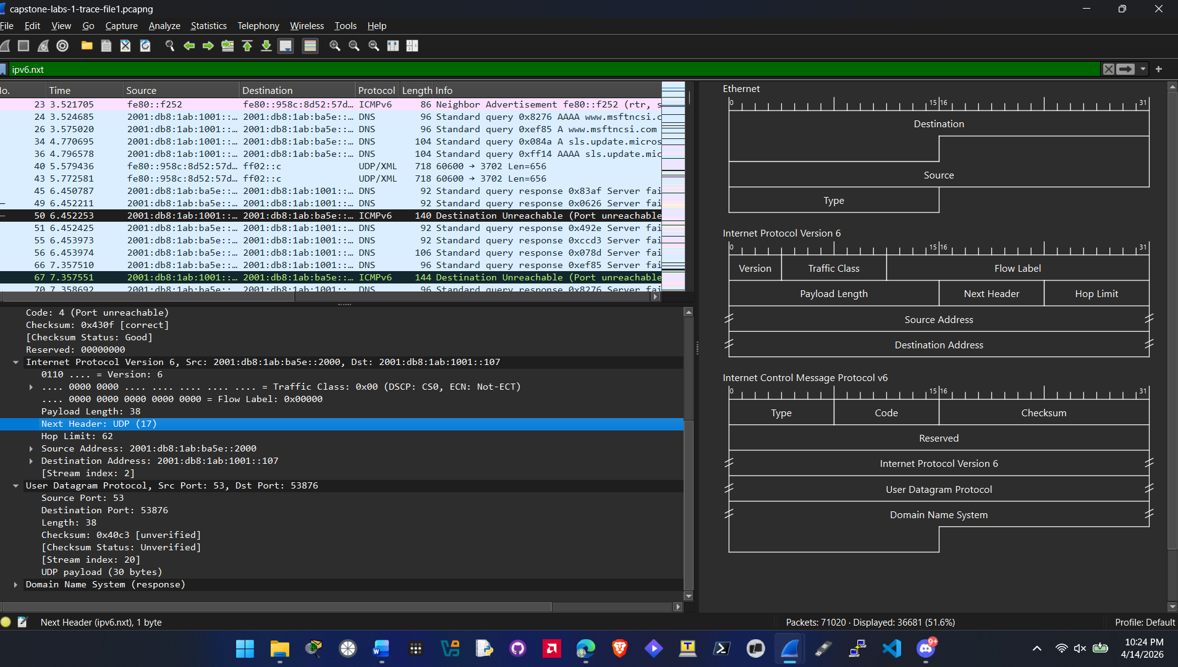
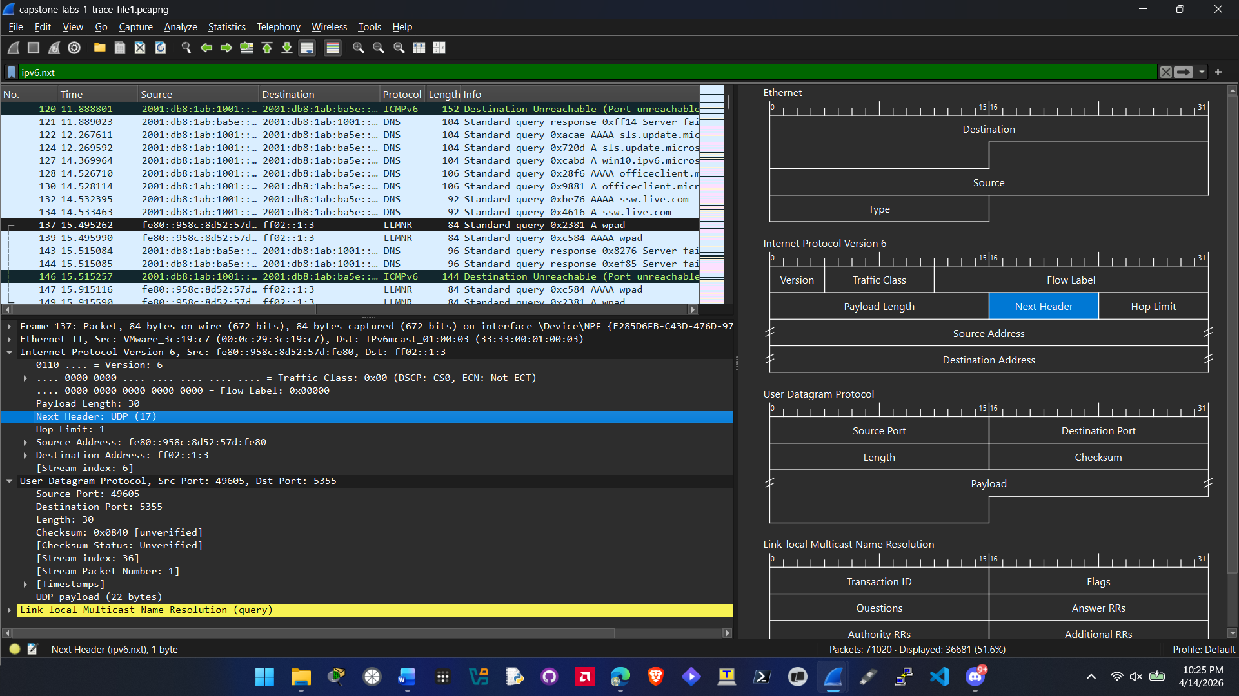

Question 9 – Please answer lab summary question.
I accomplished a couple of things in this Capstone lab. I first configured a filter for ipv6.nxt to isolate those packets. After doing that I then Identified the next header value and the layer 4 protocal associated for each packet.

Capstone Lab 2

Capstone Lab 2.1
Question 6 – Please provide screenshot showing MTU value
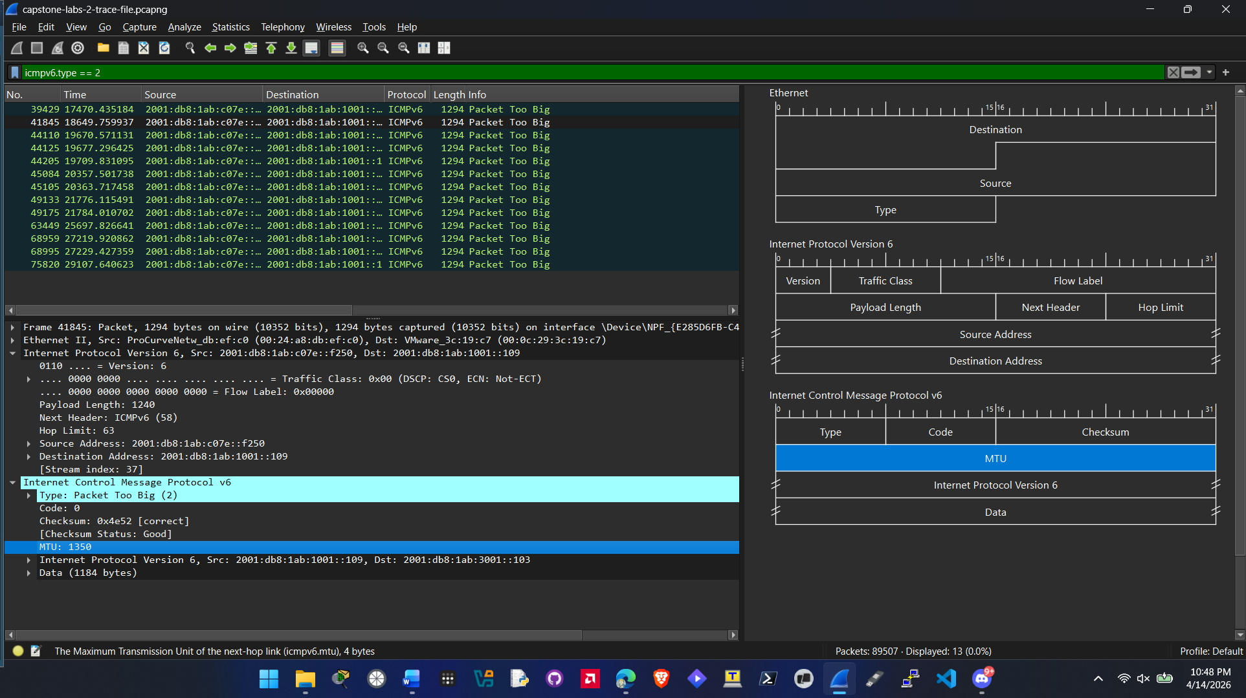

Question 7 – Please provide screenshot showing the IPv6 addresses and answer the question.
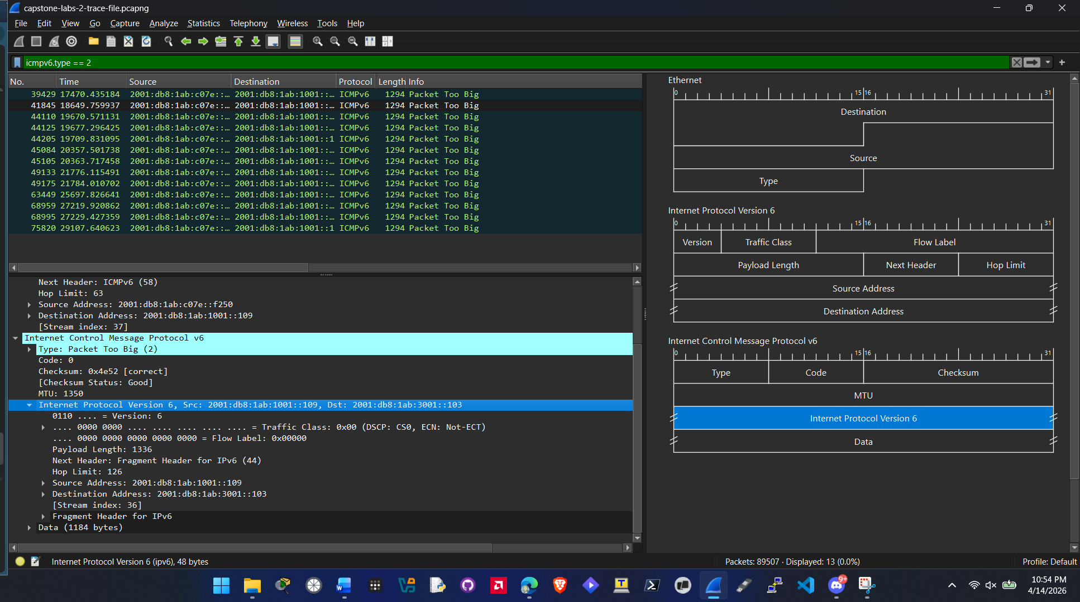
Source Address: 2001:db8:1ab:1001::109
Destination Address: 2001:db8:1ab:3001::103
The Outer address is different than the inner header address because the packet was to pick and the inside is a copy of the original source and destination address. This will tell the sender what needs to be fragmented or reduced in size.
Question 8 – Please answer question.
Yes there are different source/destination pairs in other trace files.
Question 9 – Please answer lab summary question.
I accomplished a couple of things in this Capstone lab. I filtered by a specific type of icmpv6 packet to pinpoint issues with oversized packets. I also Identified why source and destination addresses are listed differently in the layer 3 and layer 4 protocol part of ICMPv6 jumbo packets.

Capstone Lab 2.2
Question 8 – Please provide screenshot
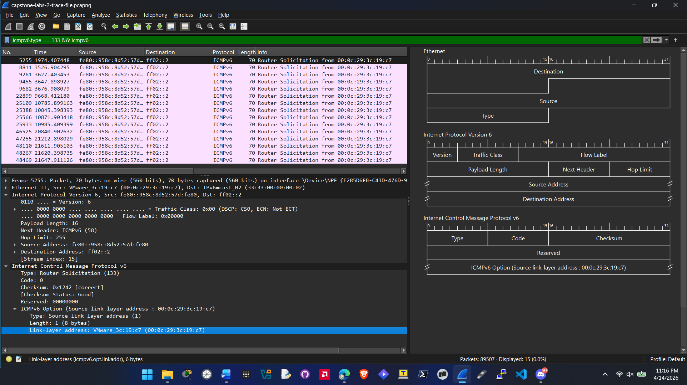
Question 9 – Please provide screenshot of the reply and answer the question

Question 10 – Please answer lab summary question.
Traced the IPv6 handshake of having no gateway information to a MAC address and a IP address. Identified the hardware identity by inspecitn the Source Link Layer address. Also filtered specific ICMPv6 type filters to isolate the solicitation packets.

Capstone Lab 2.3
Question 4 – Please provide screenshot
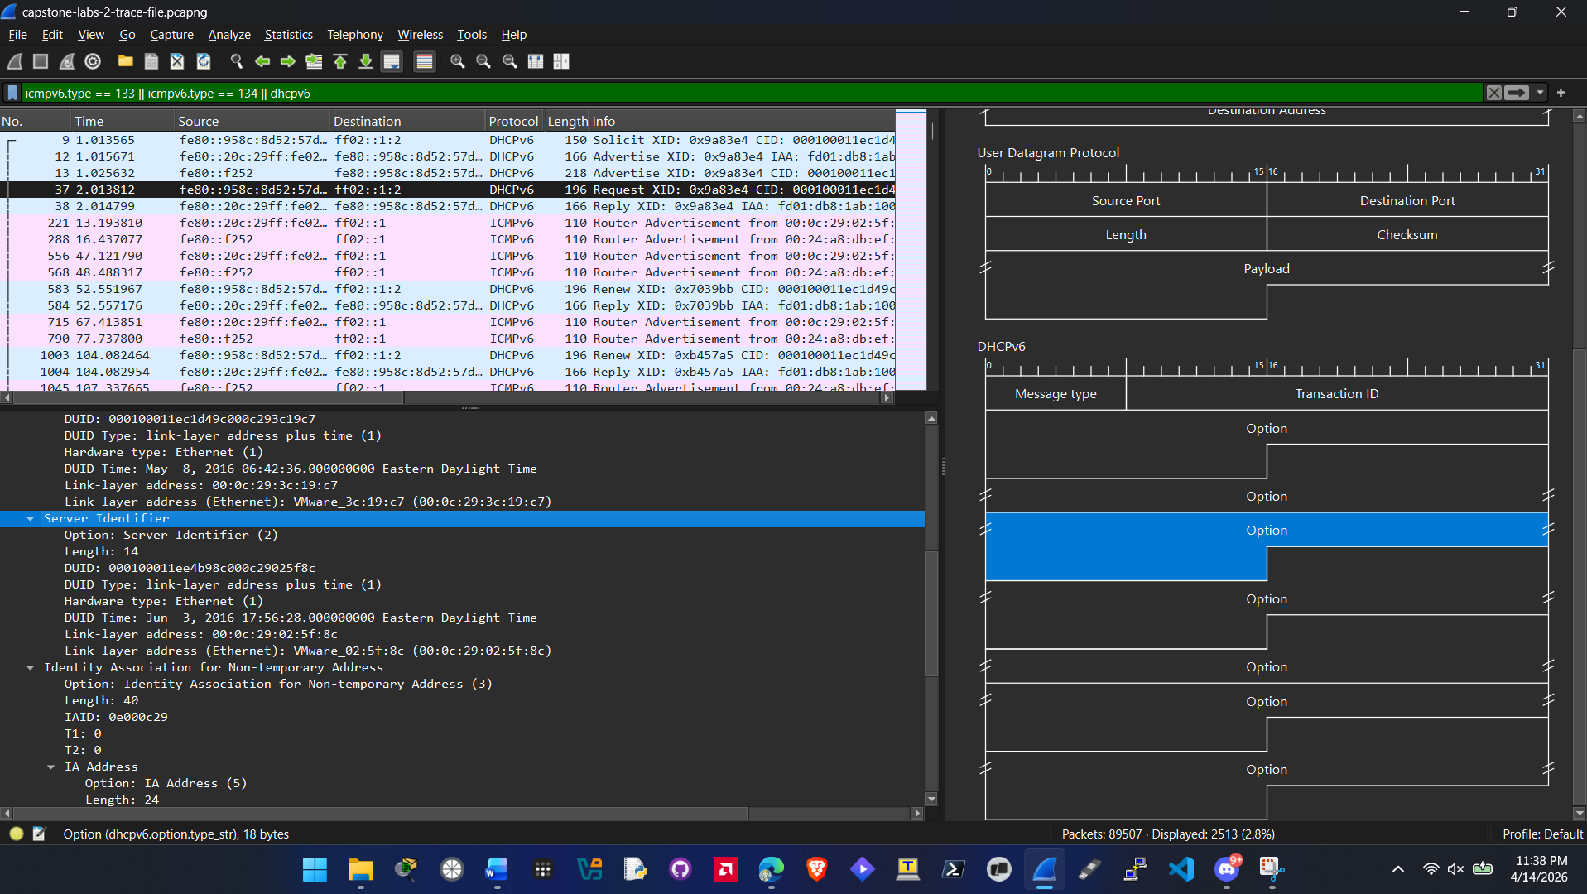
Question 6 – Please answer question.
Yes this is the valid DHCPv6 server.
Question 8 – Please answer question.
No there is no preference field in this packet
Question 9 – Please answer question.
Yes there is a preference field in the next packet it has a value of 200
Question 12 – Please answer question.
Yes, this is a known/valid router or its relay.
Bonus question 13 (Optional) – please answer the question

Question 14 (required) – Please answer lab summary question.
In this part of the capstone 2 lab I verified the leasing behavior and if the host successfully obtained the ipv6 address. I also inspected the packets for preference values in the preference field.

Capstone Lab 2.4
Question 9 – Please provide screenshot
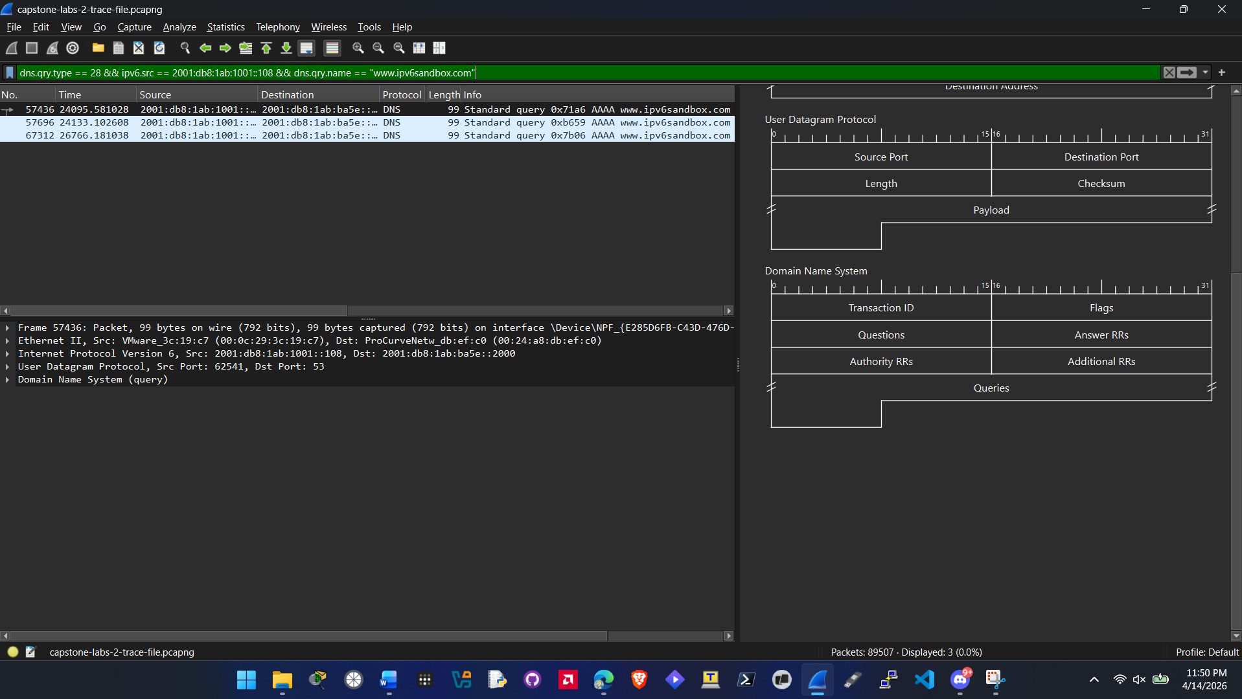
Question 10 – Please answer question.
3 packets are displayed.
Question 11 – Please answer lab summary question.
In this part of the capstone lab I isolated the IPv6 DNS traffic specifically looking for AAAA query packets. I Also learned how to make a long compound filter narrowing down the specific packets that I was looking for in question 9. I also saw how the host attempts to resolve a web address to an IPv6 address.

